UNCNCML110, UNCNCML111, UNCNCXL110, UNCNCEL110
CNC Central Unit
Reduced Data sheet

Version: 2
Date: 24.09.2026

Overview

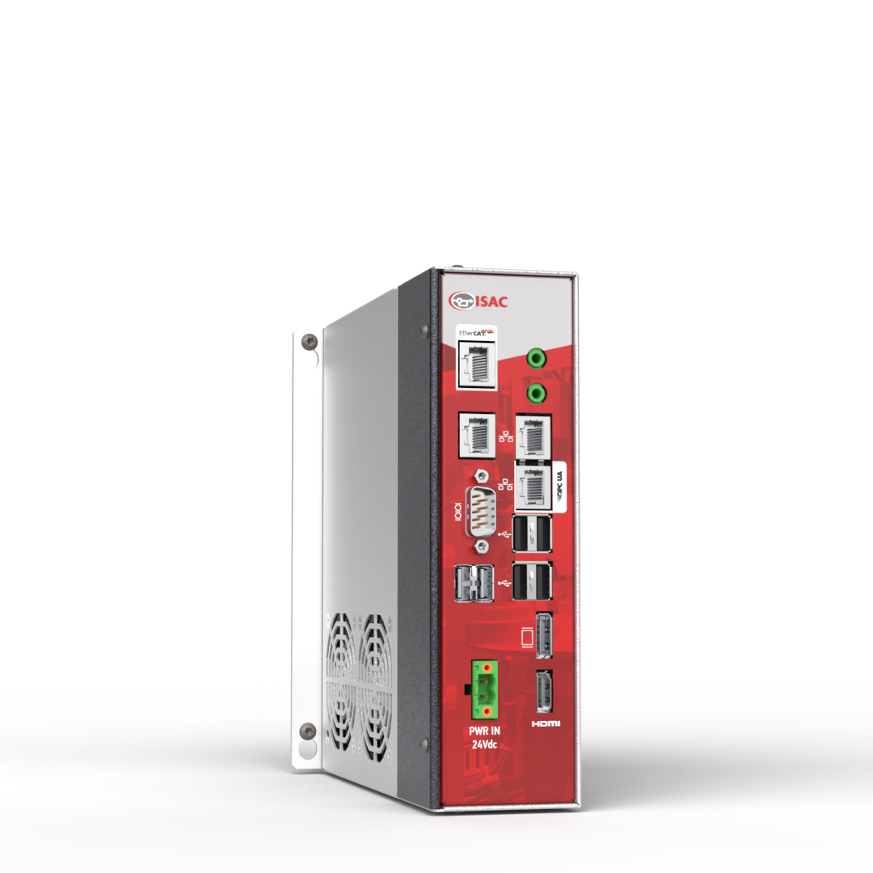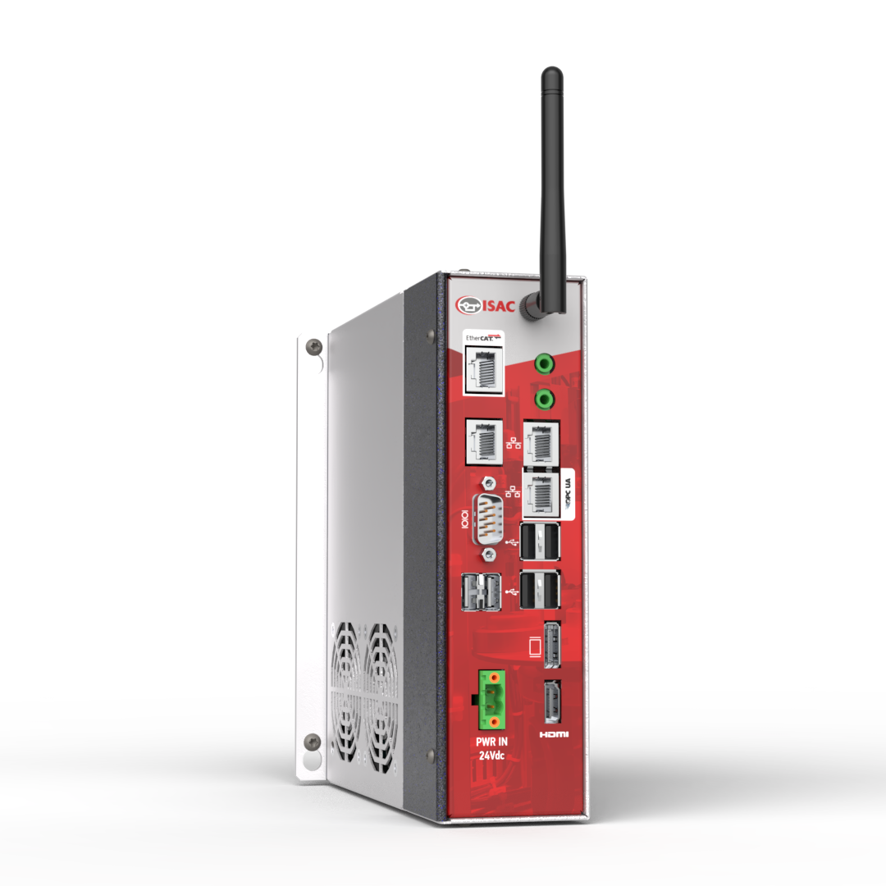
UNCNCML110, UNCNCXL110, UNCNCEL110 is a family of high performance CNC central unit capable of running complex CNC applications, and host HMI and third-parts CAD-CAM in Windows environment.

Part Number

Codes
Code | Description
UNCNCML110 | Costantino CNC central unit, W11 IoT, intel i3 13th gen
UNCNCML111 | Costantino CNC central unit, W11 IoT, intel i3 13th gen, wifi option
UNCNCXL110 | Costantino CNC central unit, W11 IoT, intel i5 13th gen, wifi
UNCNCEL110 | Costantino CNC central unit, W11 IoT, intel i7 13th gen, wifi

Alternative codes
These products replace UNCNCML00x, UNCNCXL00x, UNCNCEL00x in new applications.

Product status
Item | Value
Status | In production
In production from: | Jan 2025
In production at least until: | Jan 2030

Technical data summary

UNCNCML110/UNCNCML111
Processor System
CPU | Intel® Core Processor 13th Gen  Core™ i3-13100TE
Core Number | 4
Max Speed | 4.1 GHz
Chipset | Intel® H610
BIOS | AMI EFI 64 Mbit SPI BIOS

UNCNCXL110
Processor System
CPU | Intel® Core Processor 13th Gen  Core™ i5-13100TE
Core Number | 12 (8 P, 4 E)
Max Speed | 4.1 GHz
Chipset | Intel® H610
BIOS | AMI EFI 64 Mbit SPI BIOS

UNCNCEL110
Processor System
CPU | Intel® Core Processor 13th Gen  Core™ i7-13100TE
Core Number | 16 (8 P, 4 E)
Max Speed | 4.1 GHz
Chipset | Intel® H610
BIOS | AMI EFI 64 Mbit SPI BIOS

Common features
Operating System
 | Microsoft Windows® 11 IoT Enterprise 2024 H2 LTSC
CNC
Costantino | SWCNCCOST6
Default Axes Number | 3 interpolated
Max Axes Number | 12 interpolated + 4 independent (to be enabled w/ software options)
Max Channels Number | 4 (to be enabled w/ software option)
Min Interpolation Time | 0.5 ms
Throughput | 64,000 blocks/sec (1 channel w/ dedicated core, 3 axes CNC)
Part Program | ISO 6983 (G-code)
PLC
Standard | IEC 61131 (KW Multiprog)  Ansi C
Memory
Technology | DDR5 4800 Dual Channel
Size | 8 GB
Video
Graphics Controller | Intel® UHD Graphics 730
Max Resolution (HDMI) | 4096 x 2160 @ 60Hz
Max Resolution (DP) | 7680 x 4320 @ 60Hz
Display Memory | Shared
Physical Connections | 1x Display Port V1.4  1x HDMI V2.0
Storage
Size | 128GB
Flash | SSD 112L 3D
Interface | PCIe/NVME
Form Factor | M.2 2242
Max Data Transfer Rate | 3100/1700MB/s (R/W)
Network
Ethernet 1 controller | Intel i219LM with 10/100/1000 Mbit/s
Ethernet 2 controller | Realtek RTL8111H with 10/100/1000 Mbit/s
Ethernet 3 controller (**) | Microchip LAN9500 with 10/100 Mbit/s
Physical Connections | 3x RJ45 shielded
Wi-Fi (**)
Supported Standard | IEEE 802.11 b/g/n
Frequency Band | 2.4 GHz
Security | WEP 64/128, WPA,WPA2, TKIP,AES
Field Bus
EtherCAT controller | Intel i210
Physical Connections | 1x RJ45 shielded
Peripherals
USB | USB 2.0  USB 3.2
Physical Connections | 4x USB 2.0 type-A  1x USB 3.2 type-A  1x USB 3.2 type-C
Serial Port | COM RS-485 (Modbus RTU)
Physical Connections | 1x D-Sub 9 Male
Power Requirements
Nominal Input Voltage | Single Voltage 24V DC
Max Power Consumption | 80W
Power On | AT  (Directly Power on as power input ready)
Max Inrush Current | 4A (5ms)
Physical Connections | 1x Removable Terminal Block
Cooling
Fan | #2 60mm diameter replaceable
MTBF | 70Kh
Environment
Operating Temperature | 0 ~ 45 °C
Storage Temperature | -20 ~ 70 °C
Humidity | Up to 90% without condensation
Overall Dimension | 192 x 57 x 184 mm (HxWxD)
Weight | 2 Kg

(**) The WI-FI feature is not available for UNCNCML110

Certifications
Certification | Description
CE | EU Declaration of Conformity: EMC Directive 2014/30/UE  Standards used:  EN 61000-6-2:2019  EN 61000-6-4:2019
RoHS | Declaration of Conformity: RoHS Directive 2011/65/EU
Origin | Italy
CRA | Yes (pending)

Layout and dimension
Height | 192,0 mm
Width | 57,0 mm
Depth | 184,0 mm

Drilling Template for plate 1
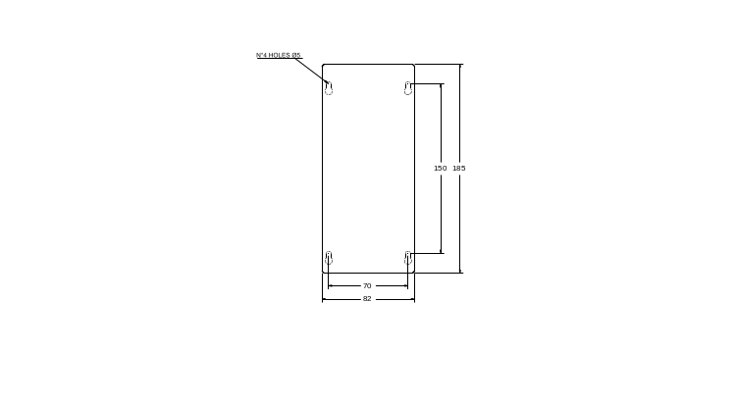
Drilling Template for plate 2 (Optional)
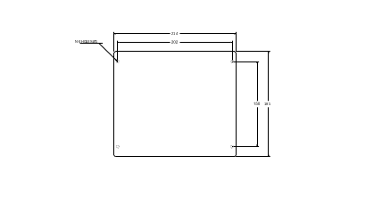

Mechanical drawing
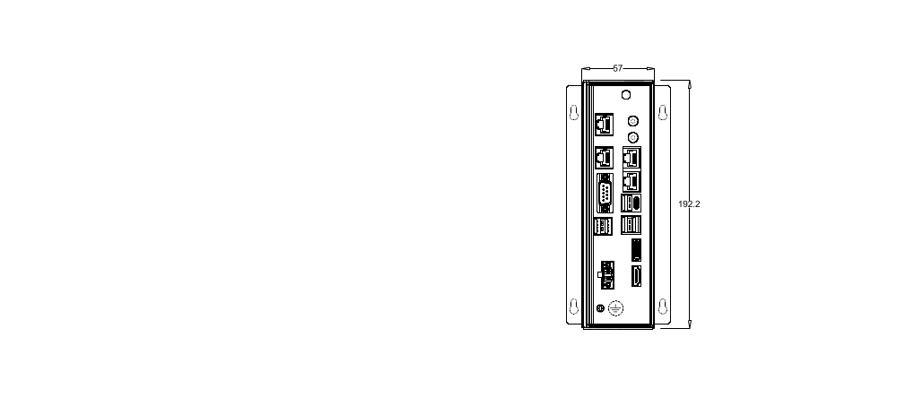
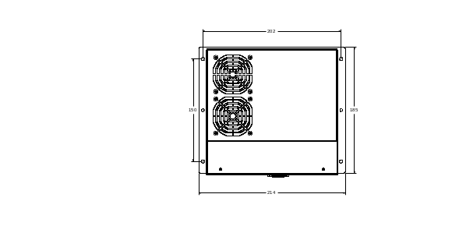
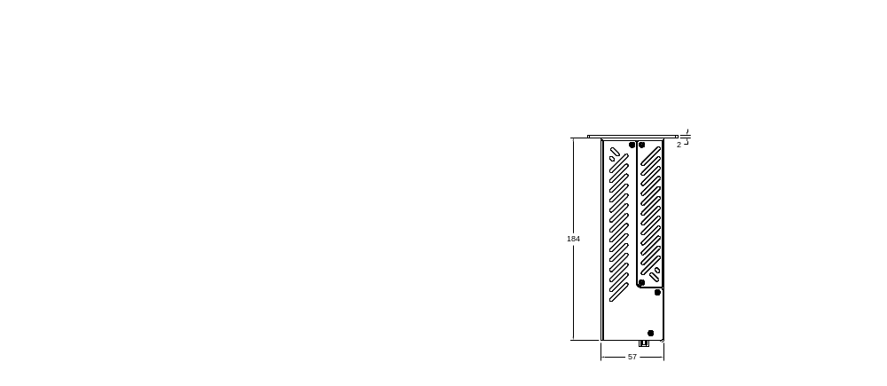

Reference documents
Full technical data sheet: TDU2001_UNCNCML110, TDU2002_UNCNCXL110, TDU2003_UNCNCEL110.
These products have a comparison performance evaluation in TABRD001_validationLists document.

